**Abdul Ghani Lone**

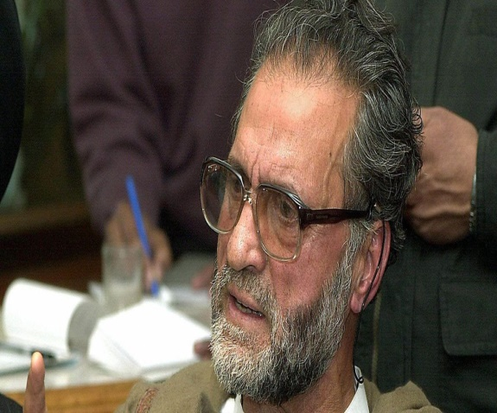

**About:**  He was the one true politician in the Hurriyat, and the rest of the Hurriyat leadership envied him for his political skills and sagacity. Born on 6 May 1932, in a far-off village in district Kupwara, Abdul Gani Lone came from a humble background, had his primary education from the village. Later on, he graduated with high grades from degree college Sopore and did LLB from the Aligarh Muslim University.  
 In the early days of his career as a lawyer, Lone began to take interest in the common man’s daily struggle against the injustices. This made him decide that he should do something for his people. Spirit was unwavering. His passion superseded all the obstacles and he began to rise and shine as a unique leader of his times. Majority of the people of his area supported him, as they knew his intention of entering politics was not some petty financial gains or fame but his passion and deep concern for the welfare of his people. His leadership qualities won people’s hearts and in a short span of time he emerged as a powerful and charismatic name in politics. In 1967, he won the State Assembly elections from Handwara and in 1971, he became the state Cabinet Minster. He then offered his resignation. After ‘Indra-Abdullah Accord” when Sheikh Mohammad Abdullah contested elections in 1977,Lone emerged victorious and people voted for him.  
 In 1978, Lone founded Jammu Kashmir peoples Conference, in which many politicians, social activists.

**Murdered on:** May 21, 2002.

**Attack details:** On May 21, 2002, the Kashmiri separatist leader, Abdul Ghani Lone, was gunned down as he attended the 12th memorial service for Mirwaiz Moulvi Farooq, at the Edgah in Srinagar’s old town.

**Reason to him target:** Abdul Ghani Lone was released in the late summer of 1992, and upon release he had a brainwave: of setting up a conglomeration of all separatist outfits, which would be called the All Party Hurriyat Conference, Hurriyat meaning freedom.

**Occupation:** He is a Lawyer and Kashmiri separatist leader.

**Belief:**  In the early days of his career as a lawyer, Lone began to take interest in the common man's daily struggle against the implications. This made him decide that he should do something for his people. Spirit was unwavering. His passion superseded all the obstacles and he began to rise and shine as a unique leader of his times.

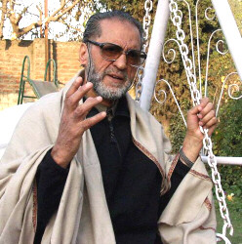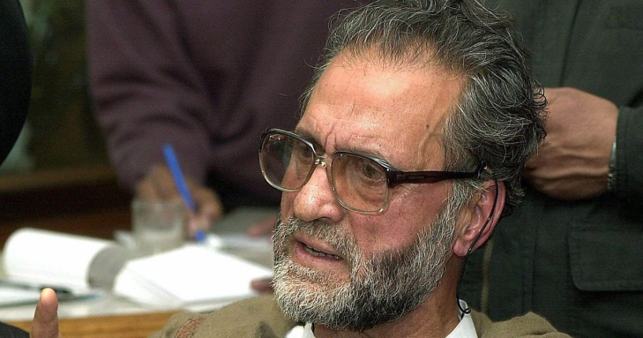**URL** : <https://scroll.in/article/838273/would-you-also-like-to-take-us-over-and-occupy-our-lands-a-kashmiri-who-questioned-both-sides>